Photosystem II Function under Extreme Low Light and Low Temperatures in Polar vs. Temperate Phytoplankton
Natasha M. Ryan¹, Mackenzie Poirier³, Pomona Osmers³, Arthur Plassart², Sébastien Guérin², Marina Cvetkovska³, Marcel Babin², Maximilian Berthold⁴, and Douglas A. Campbell^{1,✉}
2025-03-28
Abstract
Polar phytoplankton achieve slow, but ecologically significant, productivity under exceptionally low light, where sequential arrivals of photons at Photosystem II are widely spaced in time. We hypothesized that maintaining photosynthesis under such low light involves suppression of energetically wasteful photochemical ’misses’in Photosystem II. Under full darkness Photosystem II relaxes predominantly to the S1 oxidation state of the oxygen evolving complex. We then used series of single turnover, saturating, flashes to advance Photosystem II through sequential photochemical charge separations, progressively oxidizing the oxygen evolving complex, resulting in four step changes in Photosystem II chlorophyll fluorescence yield. We tracked these oscillations in chlorophyll fluorescence to measure the persistence of synchronized photochemistry across the Photosystem II populations in diatoms and green algae, in response to changing measurement temperature and a range of low light, emulated by increasing spacing of photon deliveries. Prolonged synchronous cycling indicates fewer desynchronizations from wasteful photochemical misses and, thus, more efficient photosynthetic energy conversion under low light. We observed that colder temperatures result in more sustained cycling at longer photon spacings, within taxa. Further, polar taxa maintained synchronized cycles for longer than did temperate taxa, under comparable measurement conditions. Our findings support our hypothesis that diverse lineages of polar phytoplankton suppress energetically wasteful photochemical misses under low temperature, to help sustain photosynthesis even under extremely low light. Therefore ambient temperature interacts with low light limitations on photosynthesis.
¹ Department of Biology, Mount Allison University, Sackville NB, Canada, E4L1G7
² Takuvik Joint International Laboratory, Université Laval (Canada) - CNRS (France)
³ Department of Biology, University of Ottawa, Ottawa, ON, Canada
⁴ Max Current Address
✉ Correspondence: Douglas A. Campbell <dcampbel@mta.ca>

1 To Do
Fix R package citation bibtex; only citations in main .bib on Zotero are showing up
Fix figure & table citation issue Fix table output
Scan recent literature; Gates?
process & plot tau data to track how long PSII is closed after flash
?do math or cite literature to estimate probability of double hits contributing to desynchronization and whether that probability varies with flash spacing or temperature
convert damping index to relative probability of desynchronization
(re)generate figures; do we need the missing variables?
remove Fragilariopsis grown at 0C?
run Thalassiosira pseudonana grown at lower temperature in Halifax or Sackville?
run temperate pennate diatom in Halifax or Sackville?
more Chlamy measures in Ottawa?
format for Frontiers special issue?

Introduction
Phytoplankton are a functional grouping of photosynthetic microorganisms, with diverse evolutionary histories and ecologies (Pierella Karlusich et al., 2020), which share photolithotrophic growth, harnessing light energy to reduce and assimilate inorganic carbon, nitrogen, phosphorus, sulphur, and other essential micronutrients (Raven et al., 2000). Photosynthetically Active Radiation (PAR), however, decreases with depth, as the light passing through the water column is scattered and absorbed (Kirk, 2011). Therefore, with photons as a sole net energy input, phytoplankton growth is constrained to the photic zone, the region of water receiving sufficient light for photosynthesis, operationally defined in past as extending down to a limit receiving 1% of surface irradiance, thus 2-20 µmol photons m⁻² s⁻¹ (Raven et al., 2000).
Light availability is further constrained in polar seas, presenting unique challenges for phytoplankton growth (Hancke et al., 2018; Randelhoff et al., 2020; Hoppe et al., 2024), when seasonally varying low solar angle, sea ice, and snow cover, limit the light penetrating the water (Leu et al., 2015; Hancke et al., 2018). Indeed the lower limit of the photic zone was reconsidered as benthic microalgae in the Antarctic were reported photosynthetically active at light levels less than 1 µmol photons m⁻² s⁻¹ (Robinson et al., 1995). Some polar psychrophile phytoplankton further demonstrate slow, but ecologically significant, productivity in the winter through photosynthesis below 0.15 µmol photons m⁻² s⁻¹ (Randelhoff et al., 2020; Hancke et al., 2018; Hoppe et al., 2024), with implications for the responses of phytoplankton communities to climate change (Ardyna and Arrigo, 2020).
Slow but significant phytoplankton photosynthesis during polar winters underscores the ability of psychrophilic phytoplankton to maintain functional photosystems throughout the polar night (Randelhoff et al., 2020; Hoppe et al., 2024), and supports a theoretical minimum light level for phytoplankton photosynthesis of 0.01 µmol photons m⁻² s⁻¹ (Raven et al., 2000). Such low-light phytoplankton photosynthesis and growth may serve to mitigate cell mortality in the extended darkness of winter, maintaining a seeding population for the spring bloom (Randelhoff et al., 2020). These spring blooms, in turn, are a major source of annual net primary production in polar regions (Ardyna and Arrigo, 2020).
In parallel with seasonally low light, psychrophile phytoplankton contend with cold temperature constraints on water viscosity, solute diffusion rates, membrane fluidity, enzyme kinetics and macromolecule interactions (Lyon and Mock, 2014). Some psychrophilic phytoplankton exhibit high genetic divergence from related temperate species. The polar diatom Fragilariopsis cylindrus shows divergent alleles compared to their mesophilic relatives (Mock et al., 2017), with changes in protein structure, including amino acid substitutions, H-bonds, and salt bridges (Lyon and Mock, 2014), cold shock proteins (Lyon and Mock, 2014) and anti-freeze proteins (Bayer-Giraldi et al., 2011). Polar microbes use cellular-compatible solutes, including sugars, polyols, amino acids, betaine, and DMSP, which reduce intracellular freezing points and maintain enzyme hydration spheres, stabilizing catalytic activity (Lyon and Mock, 2014). Additionally, they exhibit high levels of polyunsaturated fatty acids (PUFAs) in their lipid membranes (Lyon and Mock, 2014; Cvetkovska et al., 2022) contributing to maintainance of membrane fluidity at cold temperatures.
Oxygenic photosynthesis in eukaryotic phytoplankton occurs in chloroplasts, bounded by a two- to four-membrane envelope, depending upon taxa (Kirk, 2011). Thylakoid membranes, containing pigments and electron carriers, traverse the chloroplast stroma. Photosystem II (PSII), a multi-subunit protein complex embedded in the thylakoid membranes (Shevela et al., 2023), catalyzes the photooxidation of water, releasing O₂ and H⁺, and passing reductant into the photosynthetic electron transport chain.
In PSII, photons are captured by light-harvesting chlorophyll molecules, (Kirk, 2011), initiating a transition from the ground state to an electrically excited state. Energy absorbed by light harvesting complexes undergoes rounds of inductive resonance transfer among multiple pigments before eventually reaching the photochemical reaction center of PSII, P₆₈₀, (Kirk, 2011), composed of a Chl a heterodimer (Shen, 2021; Vass, 2011). The excitation energy is then distributed, in variable proportions, to i) photochemistry; ii) dissipation as heat; or iii) re-emission as fluorescence (ChlF) (Schuback et al., 2021). When P₆₈₀ is raised to its excited state, P₆₈₀*, it shifts reduction potential, allowing transfer of an electron to an initial pheophytin (Phe) acceptor molecule, thereby photoxidizing to P₆₈₀+ (Vass, 2011; Shevela et al., 2023). The electron from reduced Phe- is transferred to plastoquinone A (Q_{A}), followed by transfer to plastoquinone B (Q_{B}) (Shen, 2021). Q_{B}, once fully reduced by receiving two electrons, is released, carrying the electrons into the mobile plastoquinone pool in the lipid phase of the thylakoid membrane (Kirk, 2011). P₆₈₀+ returns to its ground state P₆₈₀ by taking an electron from a tyrosine residue D1-Tyr-161 (Yz). Yz, in turn, extracts an electron from a manganese cluster on the thylakoid lumenal side of PSII (Shen, 2021; Mukhopadhyay et al., 2004).
During photosynthesis, electron transfers thus stabilize separated charges (Vass, 2011). However, these charge separations are reversible through recombination reactions (Vass and Cser, 2009; Han et al., 2012), one category of photochemical ‘miss’ (Han et al., 2012, 2022), a futile cycle of photochemistry (Rappaport et al., 2002; Rappaport et al., 2005; Laloi et al., 2006). Recombinations can generate chlorophyll triplets which react with ground-state molecular oxygen to produce singlet oxygen (¹O₂), a highly damaging, photoinhibitory reactive oxygen species (Rappaport et al., 2005). Conversely, these non-radiative charge recombinations act as a mechanism of photoprotection under excess excitation (Vass, 2011), enabling direct recombination from the singlet P₆₈₀+Phe- or P₆₈₀+Q_{A}- states (Rutherford et al., 2012), to help suppress the formation of harmful ROS (Vass and Cser, 2009). Since there are activation energies for recombinations, the probabilities of recombinations vary with temperature, (Ivanov et al., 2006; Han et al., 2008; Han et al., 2012, 2022). Both plants and cyanobacteria modulate the potentials of electron transfer intermediates, changing the probabilities and temperature dependencies of recombinations (Ivanov et al., 2006; Sane et al., 2003; Sane et al., 2002; Ivanov et al., 2003).
Beyond their roles in photodamage and photoprotection, charge recombination reactions are wasteful ‘miss’ processes that lower photosynthetic energy conversion efficiency (Rappaport et al., 2005; Han et al., 2012) by competing with linear electron transport. Shifting reduction potentials of downstream electron acceptors, leading to changes in energy gaps for recombinations, may represent evolutionary adaptations aimed at maximizing photoprotection and minimizing losses through back-reactions under light-limited conditions (Vinyard et al., 2013).
The oxygen-evolving complex (OEC) of PSII consists of a manganese-oxo cluster (Mn₄CaO₅) where water is oxidized, releasing oxygen and protons (Gates et al., 2020). Four consecutive charge separations at P₆₈₀ induce four increasingly oxidized states of the Mn cluster, known as S-States (Zaharieva and Dau, 2019), denoted , from most reduced to most oxidized, as S0, S1, S2, and S3, followed by a transient S4 state, which rapidly decays to S0. Once the Mn cluster has progessively lost four electrons, the Mn cluster oxidizes two water molecules to one molecule of O₂. Therefore, a complete water oxidation cycle during oxygenic photosynthesis requires four sequential photon excitations of a single PSII, with the progressive accumulation of four oxidizing equivalents in the OEC (Dau and Haumann, 2007; Gates et al., 2020; Zaharieva and Dau, 2019).
Under light limitation, arrivals of excitations of P₆₈₀ are widely spaced in time, so electron transfer intermediates must persist for long periods of time, elevating the probabilities of energetically wasteful recombination reactions, representing a step backward in the S-State cycle (Keren et al., 1997; de Wijn and van Gorkom, 2002; Han et al., 2008). Stable and progressive S-State cycling under low light, in contrast, sustains electron flow for ATP and NADPH production, while minimizing risk of low-light photodamage to PSII (Rappaport et al., 2005; Keren et al., 1997).
We therefore evaluated whether psychrophilic polar diatoms and green algae maintain stable S-State cycling, thus enabling productive electron transport, under extremely low light and low temperatures. S-State cycling in a phytoplankton sample can be tracked by the applications of sequences of short, bright, single-turnover saturating light flashes. In darkness the PSII population relaxes primarily to S1 (Han et al., 2008). As sequential light flashes are applied, the population of PSII complexes is driven through the S-State cycle (Dau and Haumann, 2007). In an idealized sample, the four S-States will be reflected by an ongoing periodic oscillation in ChlF, since the S-States have different intrinsic fluorescence yields (Gates et al., 2020; Zaharieva and Dau, 2019). However, recombination reactions contribute to wasteful misses in the S-State cycling of individual PSII (Han et al., 2012). As misses occur, they progressively desynchronize S-State cycling among the PSII population, dampening the observed ChlF oscillation (de Wijn and van Gorkom, 2002) towards a steady state averaged ChlF for the PSII population. An organism exhibiting S-State cycling sustained over more flash cycles indicates fewer photochemical misses, and thus higher conversion of rare excitations to photosynthetic electron transport. By comparing the S-State cycling over flash cycles, of psychrophilic and temperate taxa, we sought to determine if psychrophilic diatoms and green algae show higher maintainance of progressive PSII function under extreme low light, for stable extraction of electrons from water.

Materials and methods

1.1 Study Strains and Culturing Conditions
The seven study taxa, including polar and temperate strains of diatoms and green algae, and their respective culturing conditions are summarized in Table @ref(tab:taxa_cultures).
(#tab:taxa_cultures)(#tab:taxa_cultures)Study taxa and culture growth conditions.
Taxa
Origin
Growth °C
PAR (µE)
Photoperiod (h)
Media
Thalassiosira pseudonana
Temperate
22
70
12
F2
Thalassiosira pseudonana
Temperate
22
50
12
F2
Chlorella vulgaris
Temperate
22
50
12
BG11
Chlorella vulgaris
Temperate
22
50
12
BG11
Chlamydomonas reinhardtii
Temperate
24
70
24
BBM
Fragilariopsis cylindrus
Polar
0
10
24
F2
Fragilariopsis cylindrus
Polar
6
10
24
F2
Chlamydomonas priscuii
Polar
4
10
24
BBM
Chlamydomonas ICEMDV
Polar
4
10
24
BBM
Chlamydomona malina
Polar
4
10
24
BBM
Fragilariopsis cylindrus, a psychrophilic pennate diatom measuring 15-55 µm, forms large blooms in the high salinity and subzero temperatures of Arctic and Antarctic sea-ice systems (Otte et al., 2023; Cefarelli et al., 2010), and is as a keystone species for polar ecosystems (Otte et al., 2023; Kang and Fryxell, 1992). Conversely, Thalassiosira pseudonana (Cyclotella nana) is a small (2.5-15 μm) centric diatom found worldwide in diverse freshwater, coastal, brackish, and marine habitats (Poulsen and Kröger, 2023). Thalassiosira pseudonana can tolerate a range of salinities and temperatures (4–25°C), contributing to its use as a model diatom species (Poulsen and Kröger, 2023). Chlamydomonas ICE-MDV and Chlamydomonas priscui are halotolerant algae isolated from the perennially ice-covered hypersaline Lake Bonney, in McMurdo Dry Valleys, Antarctica (Cook et al., 2019; Stahl-Rommel et al., 2022). With 15 to 20 μm biflagellate cells, Chlamydomonas ICE-MDV dominates the shallow photic zone, where it experiences relatively higher irradiance, extreme nutrient limitation, and lower salinity (Cook et al., 2019; Li et al., 2016). The smaller Chlamydomonas priscui dominates the deep photic zone, characterized by permanent low temperatures, low irradiance, and high salinity (Cvetkovska et al., 2022; Hüner et al., 2023). Chlamydomonas malina is a marine microalga isolated from the Arctic Ocean Beaufort Sea, around 10 μm in length and 5 μm in width, growing optimally at 4°C (Balzano et al., 2012; Morales-Sánchez et al., 2020). The temperate Chlamydomonas reinhardtii is a model green alga approximately 10 μm in diamter, found in soil and aquatic environments with an optimal temperature range of 20-32°C (Sasso et al., 2018; Xie et al., 2013). Chlorella vulgaris, ranging from 2 μm to 10 μm in size, is primarily found in freshwater environments and grows optimally at 27°C (Wiel et al., 2017; Leyva et al., 2014).
Cultures of Thalassiosira pseudonana and Chlorella vulgaris were prepared by Naaman Omar (Mount Allison University); Chlamydomonas cultures were prepared by Mackenzie Poirier (Cvetskova Lab, University of Ottawa); and Fragilariopsis cylindrus cultures were prepared by Sébastien Guérin (Takuvik International Research Laboratory, Université Laval).

1.2 Single Turnover Variable Chlorophyll Fluorescence
We used series of single turnover, saturating, flashes to induce variable chlorophyll fluorescence (ChlF) (Kolber, 1998), to evaluate progressive desynchronization of the S-State cycle across a range of phytoplankton species and growth temperatures. To do this we loaded a 3 mL sample of culture into a temperature-controlled water-jacketed quartz cuvette (PolyScience), placed within the measurement chamber of a Soliense fluorometer (Version LIFT-REM 1.0, Soliense Inc). The apparatus was covered to block out incident light and cells were acclimated to the dark for a minimum of 30 seconds. In the dark PSII reaction centres relax to ground state, open for photochemistry upon receipt of an absorbed photon, with a low fluorescence yield (Schuback et al., 2021). In parallel the oxygen evolving complex (OEC) relaxes primarily to S1 (Han et al., 2008), so the S-States of the population of PSII largely synchronize. The sample was then exposed to a series of 32 short, high irradiance (~ XXXXX µmol photons m⁻² s⁻¹), evenly spaced flashes centered at 445 nm. Each flash comprises a rapid series of 50-70 sub-saturating flashlets of 1.6 µs, delivered every 4.1 µs, over a total 205 - 287 µs per flash (Schuback et al., 2021). These flashlets cumulatively deliver a photon to each PSII in the population, with each ideally undergoing photochemistry and passing an electron downstream to Q_{A}-, closing PSII for photochemistry for ~1000 µs, the lifetime (𝛕) for re-opening by downstream electron transport (Dau and Haumann, 2007; Schuback et al., 2021). Closing the photochemistry pathway transiently redirects a greater proportion of additional incoming excitation to ChlF, driving ChlF progressively from minimum (F_{O}) towards a maximum (F_{M}) as the PSII centres close (Schuback et al., 2021). For each flash, F_{O} and F_{M} are extracted using a fitting model (LIFT software version 22.11.11, Solisense Inc) (Kolber, 1998). F_{O} and F_{M} can then be used to derive the maximum quantum yield of photochemistry for open PSII (Schuback et al., 2021), a secondary ChlF parameter calculated as :
$$F_{V}=\frac{F_{M}}{F_{O}}$$
For each culture sample we adjusted the number and excitation power of flashlets per flash to achieve closure of ~ 0.95 of PSII complexes, as estimated by the fitting of the chlorophyll fluorescence induction (Kolber, 1998; Schuback et al., 2021). Ideally the saturating flash would achieve complete closure of the PSII population, but concomitant re-opening of PSII by downstream electron transport results in a steady state ratio of mainly closed PSII to a fraction of open PSII, even at F_{M}. The flash power required to drive the PSII population to closure depends largely upon the effective absorption cross-section of photosystem II (σ_{PSII}), itself estimated from the ChlF induction curve during the saturation phase (Kolber, 1998). σ_{PSII} represents the probability of light capture by the PSII antenna bed associated with the dark-adapted PSII (Schuback et al., 2021; Xu et al., 2018). When σ_{PSII} for a sample is large, weaker or fewer flashlets are required to saturate the population of PSII, while limiting excitation stress or double turnovers of PSII associated with excess light (Xu et al., 2018). Conversely, a sample with a smaller σ_{PSII} requires brighter, or more numerous, flashlets, to drive the proportion of closed reaction centres progressively towards saturation. If the brightness and number of sub-saturating flashlets are appropriate for the culture, the fluorescence will reach a plateau after approximately 70-80% of the flashlets (Kolber, 1998).
We kept the single turnover excitation flash train as short as feasible, to avoid excessive excitation, and to limit the probability of ‘double hits’ (Han et al., 2012, 2022); re-openings of PSII, followed by re-closures of PSII complexes by a second round of photochemistry, which contribute to desynchronization of the progression of the PSII complexes through S-States. Thus, as sequential flashes are applied to the culture, each individual PSII is ideally driven through the four S-States (Fig @ref(fig:rep_osc)) (Dau and Haumann, 2007). As the oxygen-evolving complex of PSII moves between S-States, it alters the system kinetics and free energy (Vinyard et al., 2013), and the yield of ChlF varies between S-States (Gates et al., 2020), so we can use ChlF to monitor S-State progression.
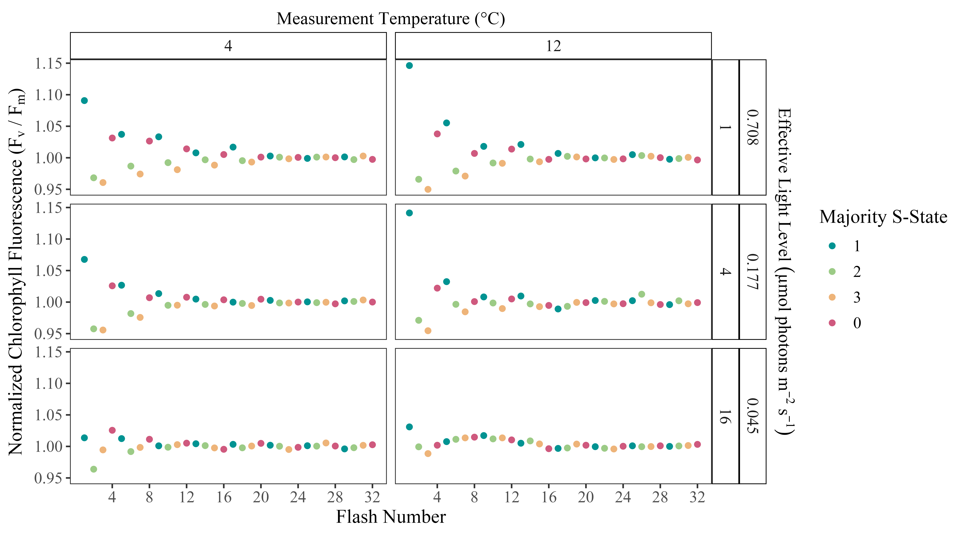
(#fig:rep_osc)Oscillations of the maximum quantum yield of PSII photochemistry over a Series of Single Turnover Saturating Flashes. F_{V}/F_{M} was normalized to the average value over the series for comparison across samples of Chlamydomonas priscui, measured at 4 or 12 °C, with spacing of 1, 4, or 16 s between sequential flashes, excitation rates equivalent to irradiance with 0.708, 0.177 or 0.044 µmol photons m⁻² s⁻¹. Symbol colour indicates inferred majority S-State, based upon relaxation to S1 during the dark incubation preceding the flash sequence.

1.3 Measurements
By evaluating the oscillations in ChlF (Fig @ref(fig:rep_osc)), we tracked S-State cycling of polar and temperate taxa of diatoms and green algae under a range of measurement temperatures and effective light levels (@ref(tab:fluor_meas)), to determine if polar taxa maintain synchronized PSII function, as an index of their capacity for electron transport under low light, by suppressing wasteful photochemical misses. While light absorption and excitation energy transfer within PSII are not temperature-sensitive, the redox reactions associated with downstream electron transport are highly temperature-dependent (Hüner et al., 2023). Furthermore, the probability of charge recombinations decrease below room temperature (Ivanov et al., 2006; Han et al., 2008), as temperature drops below the activation energies for recombination paths. This temperature dependence may interact with acclimatory mechanisms to regulate photosynthetic electron flow, S-State transitions, and energy partitioning (Hüner et al., 2023). Measurement temperatures ranged from 0 to 28°C, depending on the taxa (@ref(tab:fluor_meas)).
Increasing the spacing between sequential flashes decreases the repeat rate for excitations arriving at PSII, thereby approximating the decrease in excitations delivered to PSII per s under a decrease in continuous irradiance (Fig @ref(fig:rep_osc)). Our instrument control limited our minimum flash spacing to 1 s, so cultures were evaluated at flash spacings of 1, 2, 4, 8, and 16 seconds (@ref(tab:fluor_meas)). The equivalent effective light levels are then estimated using the σ_{PSII} determined for each culture as follows:
$$Light(µmolphotonsm^{-}2^{s^{-}}1^{)}=\frac{1}{flashspacing\left(s\right)|}$$
$$ Light (\mu mol \photon m^{-2} s^{-1}) = \frac{1}{flash spacing (s)} * {\frac{1}{\sigma_{PSII} (A^{2})} * \frac{1 m^{2}}{1E20A^{2}} * \frac{\mu mol}{6.022E17} $$
Since the population of PSII starts predominantly from S1 in the dark acclimated state, the population of PSII will initially cycle synchronously through S States, reflected by an oscillation in chlorophyll fluorescence with a period of four (Fig @ref(fig:rep_osc))(de Wijn and van Gorkom, 2002). Photochemical misses, including recombination reactions causing loss of charge separation in a PSII, will cause a missed step in the S-State cycling of an individual PSII. As more photochemical misses occur, desynchronization of S-State cycling among the population of PSII will scramble the periodic changes in ChlF, dampening the observed oscillation of the population-level fluorescence (de Wijn and van Gorkom, 2002; Han et al., 2022). Prolonged synchronous cycling thus reflects a lower probability of desynchronization at each excitation, and thus a lower probability of losses through photochemical misses. Photochemical double hits also contribute to desynchronization (Han et al., 2022; Han et al., 2008), but should not vary strongly across changes in flash spacing nor temperature within a sample.
XXXextract plots tau vs. temperature to justify this argument?XXX
The conversions of flash spacing to equivalent effective light levels gave similar ranges of light levels applied to each strain (@ref(tab:fluor_meas)). For comparison, full sunlight at the sea surface is ~ 2000 µmol photons m⁻²s⁻¹ and the threshold for the bottom of the photic zone supporting photosynthetic productivity in the oceans is conventionally defined as ~ 20 µmol photons m⁻²s⁻¹ (Raven et al., 2000). Therefore, our measurement light ranges are ~ 5 orders of magnitude lower than full sunlight, and ~ 2-3 orders of magnitude below the minimum photic zone threshold, but span light ranges found to support phytoplankton productivity in field studies (Hancke et al., 2018; Randelhoff et al., 2020; Hoppe et al., 2024).
XXXredo this as data with conversionsXXX
(#tab:fluor_meas)(#tab:fluor_meas)Study taxa and single turnover saturating flash measurement conditions, with equivalent effective light levels (µmol photons m⁻²s⁻¹).
Taxa
Flash Spacings (s)
Equivalent Light (µE)
Measurement Temperatures (°C)
Thalassiosira pseudonana
1, 2, 4, 8, 16
0.02428 - 0.53428
10, 14, 18, 20, 22, 24, 28
Chlorella vulgaris
1, 2, 4, 8, 16
0.05102 - 0.89781
10, 14, 18, 22, 26
Chlamydomonas reinhardtii
1, 2, 4, 8, 16
0.04670 - 0.84377
12, 16, 20, 24
Fragilariopsis cylindrus
1, 2, 4, 8, 16
0.02981 - 0.65678
0, 2, 6, 10
Chlamydomonas priscuii
1, 2, 4, 8, 16
0.04289 - 0.77084
4, 8, 12
Chlamydomonas ICEMDV
1, 2, 4, 8, 16
0.04252 - 0.73733
4, 8, 12
Chlamydomona malina
1, 2, 4, 8, 16
0.03705 - 0.65817
4, 8, 12

1.4 Analytical Methods
Data was processed using R version 4.3.2 (R Core Team, 2023) and RStudio version 2023.12.0+369 (Posit team, 2025) on the x86_64-apple-darwin20 (64-bit) platform and running under macOS Sonoma 14.3.1. Fluorescence data files generated by LIFT software were imported, tidied and combined with metadata on each culture using the tidyverse (Wickham, 2023), lubridate (Spinu et al., 2024), and googlesheets4 (Bryan, 2023) packages. The doBy (Halekoh and Højsgaard, 2025), and WaveletComp (Halekoh and Højsgaard, 2025) packages were used for wavelet analyses. The mgcv (Halekoh and Højsgaard, 2025) and mgcViz (Halekoh and Højsgaard, 2025) packages were used for generalized additive modelling, while the ggplot2 (Halekoh and Højsgaard, 2025) , ggh4x (Halekoh and Højsgaard, 2025), and metR (Halekoh and Højsgaard, 2025) packages were used for data visualization. Statistical results tables were done using the packages ‘broom’ (Robinson et al., 2024), ‘knitr’ (Xie, 2025), and ‘kableExtra’ (Zhu, 2024).

1.5 Wavelet Transformations
The fluorescence data yields a time series of F_{V}/F_{M} over 32 sequentially applied flashes, for each flash spacing, and each measurement temperature, for each culture sample. The F_{V}/F_{M} time series were analyzed for each combination of strain, growth conditions, measurement temperature, and flash spacing, using wavelet transformations (Theis and Meyer-Bäse, 2010), as exemplified in (Fig @ref(fig:rep_recon)). Unlike traditional methods, wavelet analysis does not assume that the statistical properties of a time series are constant. Instead, wavelet transformations locally decompose the signal across different time scales and estimate spectral characteristics as a function of time (Cazelles et al., 2008). By examining the frequency and wavelet power spectra, we can uncover the dominant patterns in the data (Theis and Meyer-Bäse, 2010).

(#fig:rep_recon)Representative wavelet transformations of Antarctic Chlamydomonas priscui variable chlorophyll fluorescence (F_{V}/F_{M}) measured at 4, 8 or 12°C, over 32 consecutive single turnover saturating flashes, applied at spacings of 1, 2, 4, 8, 16 s, equivalent to photon delivery rates to PSII achieved under light levels from 0.708 down to 0.045 µmol photons m⁻² s⁻¹.
The wavelet transformation involves computing the wavelet power spectrum of the standardized time series using the Morlet wavelet (Theis and Meyer-Bäse, 2010). The statistical significance of the periodic components in the time series was then calculated using a simulation algorithm. Surrogate time series are generated based on a white noise model, consisting of uncorrelated random values with constant mean and variance. The wavelet transform of the data is compared with the white noise model, to estimate p-values for whether the observed periodic components are statistically significant (Theis and Meyer-Bäse, 2010). Statistical significance of the wavelet power at a periodicity of four indicates the culture is exhibiting periodic oscillations in chlorophyll fluorescence, reflecting synchronous S-State cycling across the PSII population. For wavelets exhibiting detectable S-State cycling, we generated a reconstruction limited to areas with a statistically significant signal statistically different from the average value of F_{V}/F_{M}. We then extracted a Damping Index as the number of flashes applied before desynchronization results in the reconstructed wavelet dropping below a detection threshold significance of p=0.05 above random noise. This Damping Index indicates how many successive photochemical charge separations occur in the PSII population before recombinations, other photochemical misses, or photochemical double hits, desynchronize the S-State cycle to a randomized distribution of S-States across the population.

1.6 Generalized Additive Modelling
The observed patterns in the persistence of S-State cycling across conditions within taxa were then modelled using the nonparametric method of generalized additive modelling (GAM). GAMs fit a model to predict the damping index based on a tensor product smooth of the two predictors, temperature, and light level. The response variable is linked to the independent variables using a smoothing function, where many localized polynomials are joined to form a piecewise function called a spline (Pinilla and Negrín, 2021). For each strain, GAM models were fit to the data using the restricted maximum likelihood method (REML).
The GAM model (Table @ref(tab:gammodel_temp)) examines the response of S-State damping to the measurement temperature (°C) and the equivalent effective light level (µmol photons m⁻² s⁻¹) for the measurement flash spacing. Models were validated by verifying the choice of basis dimensions (k) and evaluating the residual plots (Schoenig et al., 2023). Based on the fitted models, the damping index can then be predicted for other combinations of temperature and light (Wood, 2017). These predictions were then visually represented with a contour plot.

Results

1.7 Single Turnover Variable Chlorophyll Fluorescence
Exposing phytoplankton cultures to a series of 32 successive flashes produced oscillations in the maximum quantum yield of photochemistry in PSII, as estimated through the secondary chlorophyll fluorescence parameter F_{V}/F_{M}. Initially, the majority of the dark-adapted population of PSII is at S1, with a smaller fraction at S0 (Gates et al., 2020; de Wijn and van Gorkom, 2002). As shown in Fig @ref(fig:rep_osc) and Fig @ref(fig:rep_recon), the time series of F_{V}/F_{M} over successive flashes reveals consistent variations in fluorescence yield as the predominant S-States, with different yields for ChlF, follow each other across the PSII within the population. However, the amplitudes of the ChlF oscillations declines progressively over time, and with wider spacing of sequential flashes, equivalent to decreasing effective light levels, and is less persistent at a higher measurement temperature

1.8 Wavelet Analysis
Wavelet transformations were computed for the fluorescence time series of each unique combination of measurement temperature, flash spacing, growth temperature, and species or strain. Assessing the wavelet power of a 4-step periodicity across conditions, key trends emerge. As exemplified by the Antarctic green alga Chlamydomonas priscui (Figure @ref(fig:cpriscuii_waveletpower)), the average wavelet power declines with increasing flash spacings, equivalent to decreasing effective light levels, and also with increasing measurement temperatures.
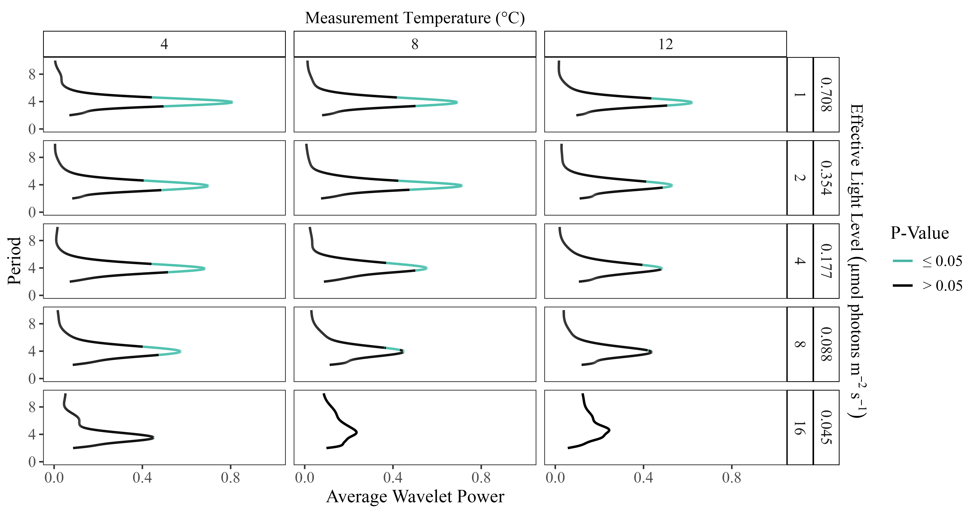
(#fig:cpriscuii_waveletpower)Sample plot of wavelet powers by period of oscillations in the maximum quantum yield of photochemistry Antarctic green algae Chlamydomonas priscui, grown at 4°C, and measured across a range of measurement temperatures and flash spacings, with the equivalent effective light levels. Regions where wavelet power reached statistical significance (p < 0.05) shaded in blue.
In contrast, in the temperate green algae Chlamydomonas reinhardtii (Figure @ref(fig:creinhardtiii_waveletpower)), the wavelet power is consistently lower, showing a weaker 4-step periodicity of ChlF in temperate taxa, which only reaches statistical significance at shorter flash spacings, with higher equivalent effective light levels.
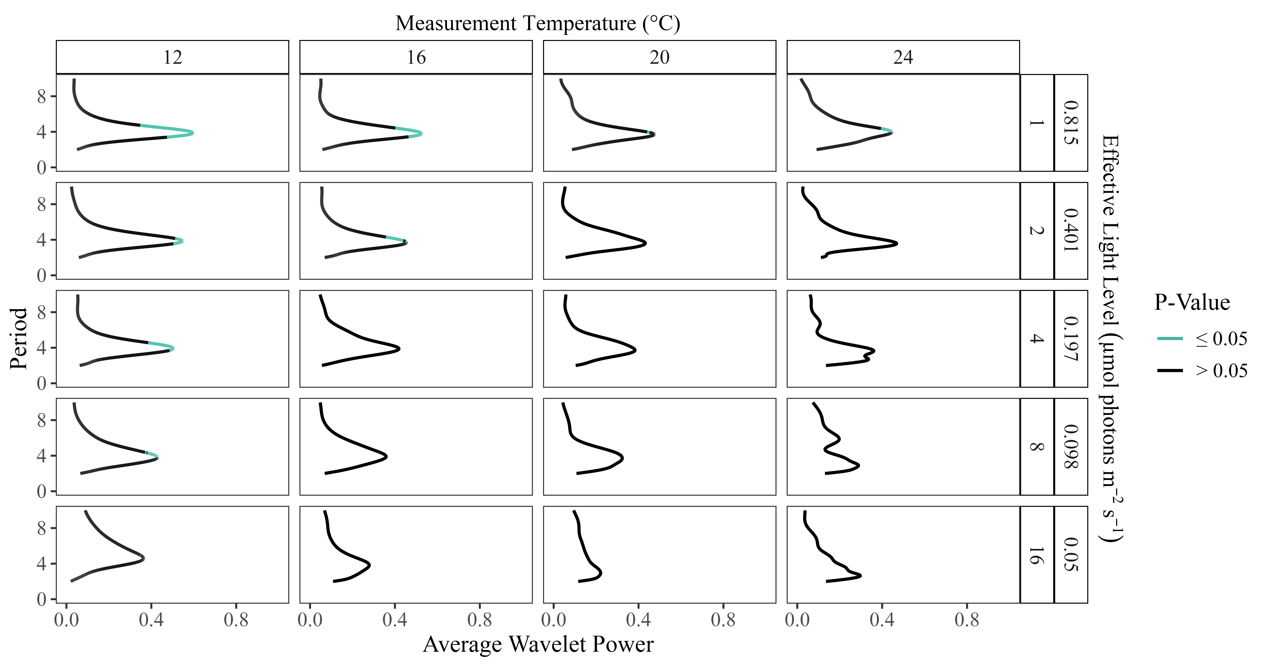
(#fig:creinhardtiii_waveletpower)Sample plot of wavelet powers by period of oscillations in the maximum quantum yield of photochemistry in the temperate green algae Chlamydomonas reinhardtii, grown at 4°C, and measured across a range of measurement temperatures and flash spacings, with the equivalent effective light levels. Regions where wavelet power reached statistical significance (p < 0.05) shaded in blue.
Polar taxa maintained significant 4-step oscillations in F_{V}/F_{M}, and thus stronger synchronization of PSII S-State cycling at longer Flash Spacing intervals, and thus at lower equivalent effective light levels, than did their temperate counterparts (Figure @ref(fig:periodicity_mtrx)), including measures taken at a common temperature of 12°C.
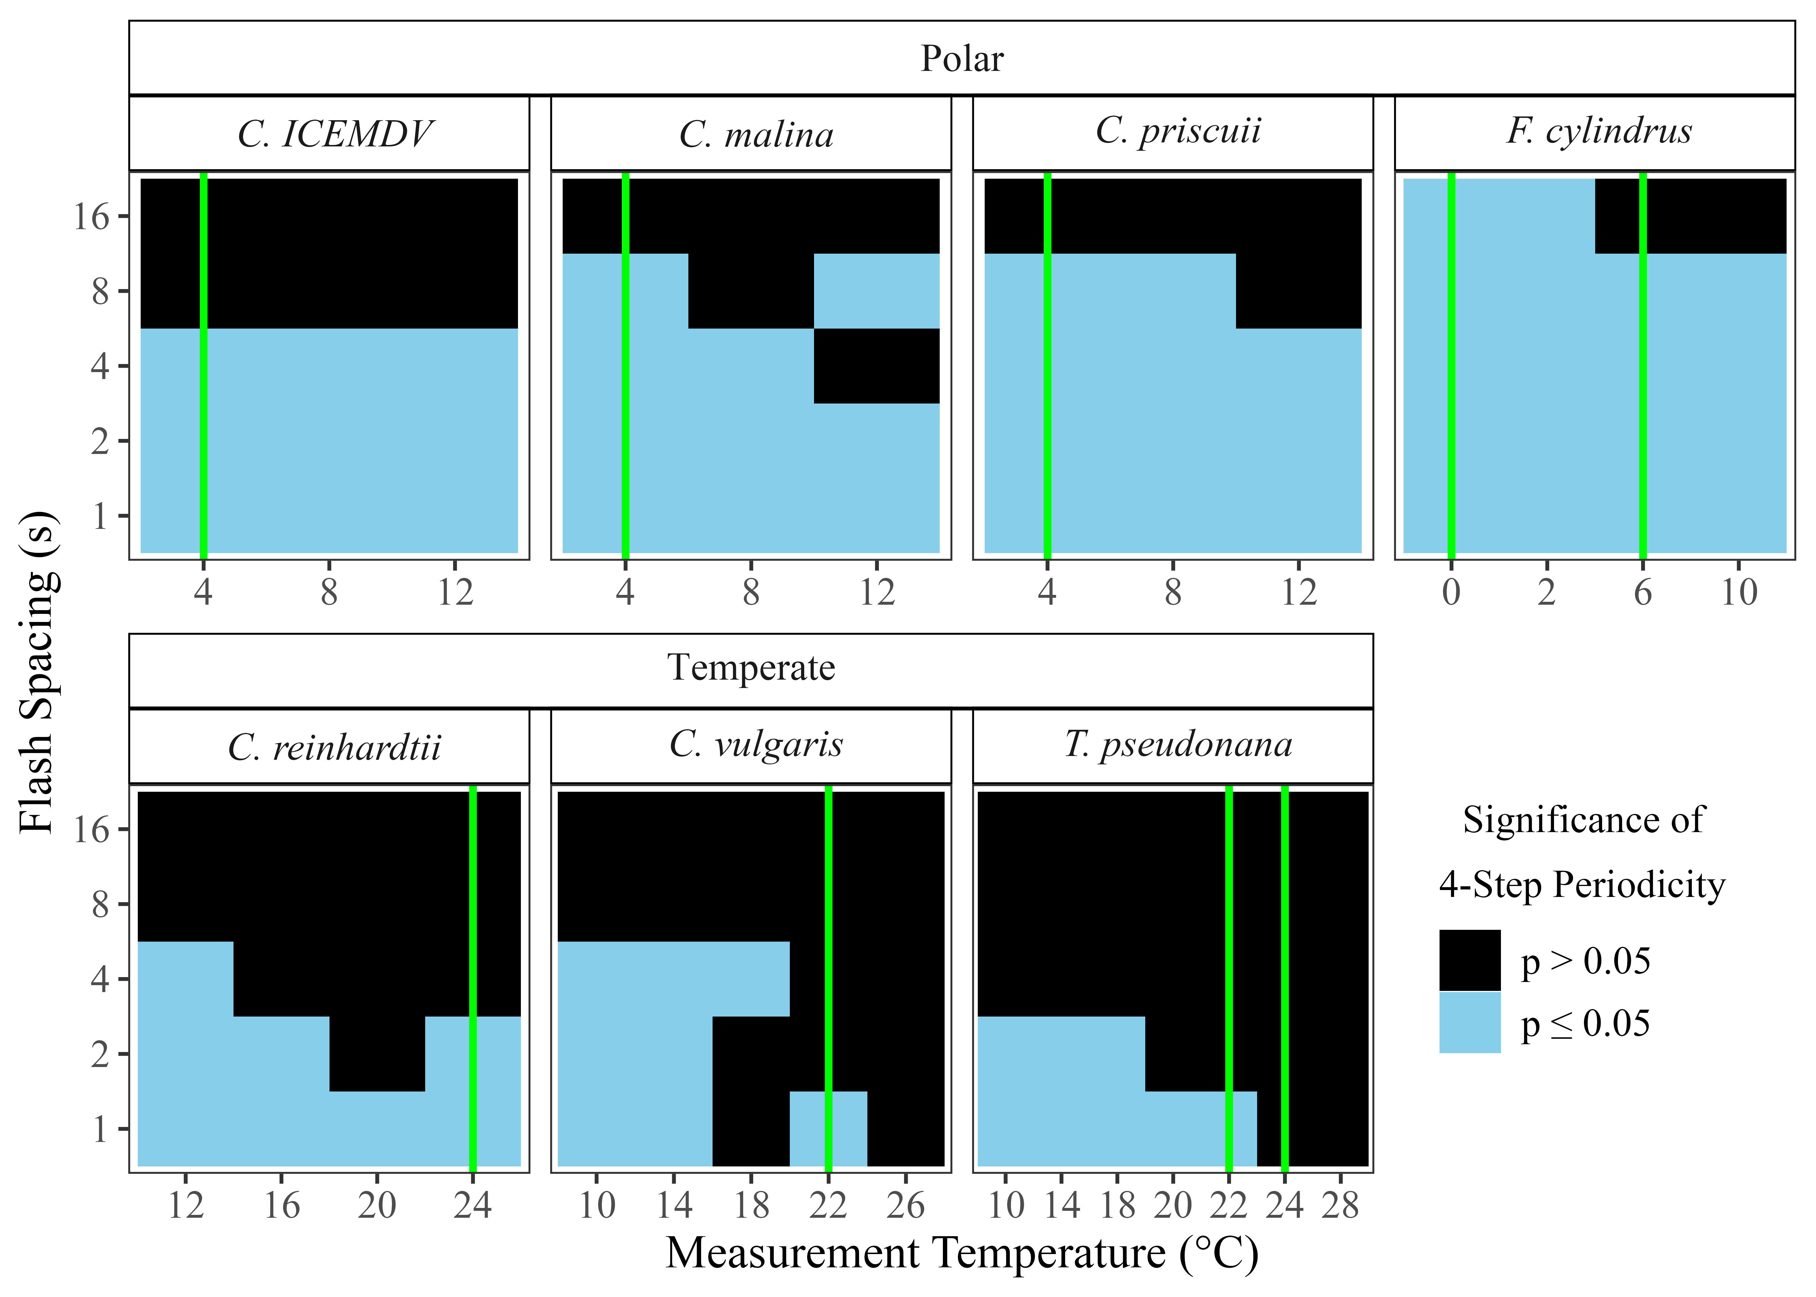
(#fig:periodicity_mtrx)Statistical significance of 4-step oscillations in the maximum quantum yield of PSII photochemistry across polar and temperate phytoplankton taxa, as measured through variable chlorophyll fluorescence. Vertical green lines indicate growth temperature(s) for respective taxa. Measurement conditions where wavelet power for 4-step periodicity reached statistical significance (p < 0.05) shaded in blue.

1.9 Generalized Additive Modelling of Damping of 4-step oscillations By Measurement Temperature
Predictions from generalized additive modelling were generated for the damping of S-State-induced chlorophyll fluorescence oscillations, as predicted by the tensor product smooth of the temperature during measurements (°C) and the equivalent effective light level (µmol photons m⁻²s⁻¹; (Table (Tab @tab(fig:gammodel_temp))), Figure (Fig @ref(fig:fluor_meas))) set by flash spacing, for each strain. For Thalassiosira pseudonana, Chlamydomonas ICE-MDV, Chlamydomonas priscui, Chlamydomonas malina, Chlamydomonas reinhardtii, and Chlorella vulgaris, all replicate cultures of each taxa were grown at the same temperature (Table (Tab @tab(fig:gammodel_temp))). The polar diatom Fragilariopsis cylindrus was cultured at both 0 and 6°C. Thus, separate models were fit for each Fragilariopsis cylindrus culture to account for possible physiological differences resulting from the distinct growth conditions. All of the model fits explained over 50% of the variation in the response variable. Both diatom taxa exhibited the longest predicted periodic oscillations in ChlF at higher effective light levels and lower temperatures. Notably, the polar Fragilariopsis cylindrus sustained cycling longer than its temperate counterpart, Thalassiosira pseudonana, under comparable conditions. This disparity was particularly prevalent at measurements taken above the growth temperature and when longer spacing between flashes produced lower effective light levels (Fig @ref(fig:diatoms_gamtemp)). Under these conditions, Thalassiosira pseudonana cultures did not retain the significant 4-step oscillation in ChlF indicative of synchronized S-State cycling.
The GAM outputs varied more among the green algae tested (Table (Tab @tab(fig:gammodel_temp))). For Chlamydomonas priscui the three measurement temperatures, limiting the number of basis dimensions used to create the smooth function (k) to 3 (Schoenig et al., 2023), proved insufficient to capture the underlying relationship between the predictors and the response variable (Table A2). Chlamydomonas malina showed a significant outlier (measurement temperature of 12 °C and a 2-second interval between flashes) in the model training data (see model training dataset at XXX GitHub: S-State Damping), as evaluated by Cook’s distances (Yager, 1998). Removing this outlier point increases the variation explained by the model from 60.2 to 75.2 % and produces a significant smooth term (F = 4.544, p = 0.0255). Overall, model predictions for green algal strains exhibited a similar pattern to the diatoms, with the longest predicted oscillations in ChlF at measurement conditions with higher effective light levels (shorter spacing between flashes) and lower measurement temperatures relative to growth temperature (Fig @ref(fig:greens_gamtemp)). The trends shown by the three strains of polar algae are consistent, differing by only 1-2 flashes before signal damping, under identical conditions (Fig @ref(fig:greens_gamtemp)). Further, much like the temperate diatoms, the temperate algae Chlamydomonas reinhardtii and Chlorella vulgaris did not exhibit significant periodic oscillations in ChlF at measurement temperatures near or above their growth temperature under longer flash spacings equivalent to lower light.
#do this as output of model not retyped
(Fig @ref(fig:diatoms_gamtemp)).
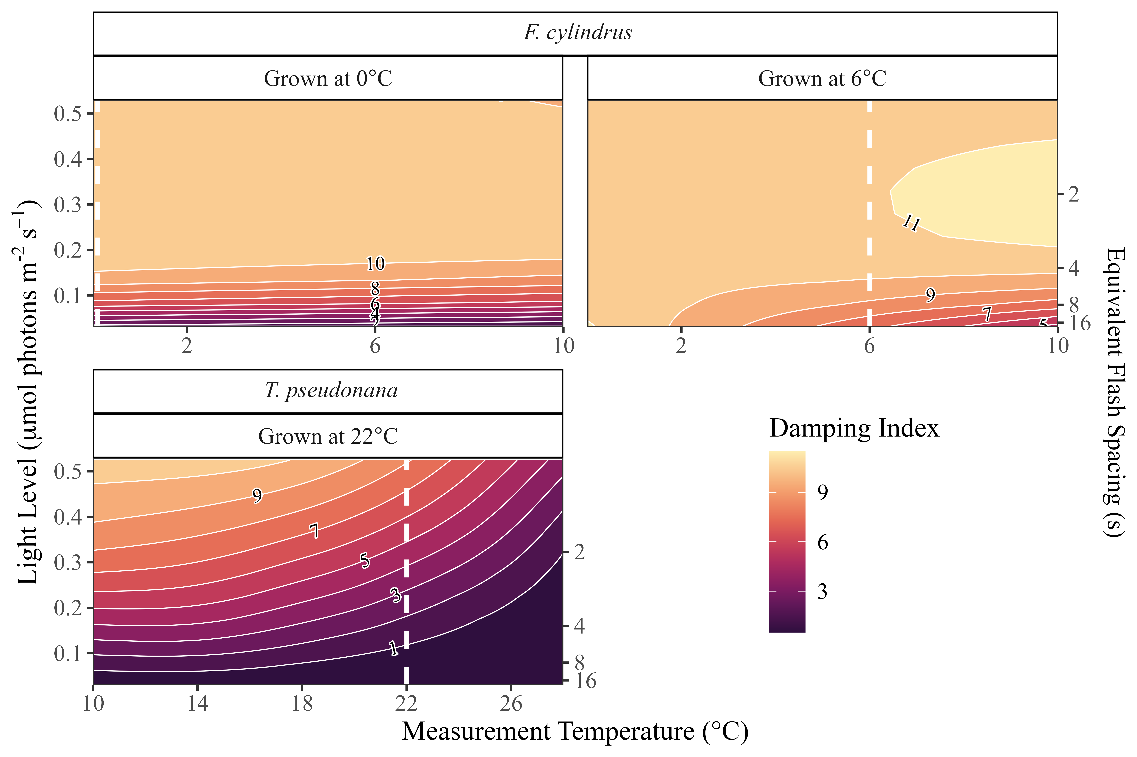
(#fig:diatoms_gamtemp)GAM models for polar and temperate diatoms, of consecutive flashes before damping of S-State-induced chlorophyll fluorescence oscillations. GAM model predicted by the temperature (°C) imposed during measurements and the effective light level (µmol photons m⁻²s⁻¹, estimated from flash spacings in seconds). White dashed vertical lines represent the growth temperatures.
(Fig @ref(fig:greens_gamtemp)).

(#fig:greens_gamtemp)GAM models for polar and temperate green algae, of consecutive flashes before damping of S-State-induced chlorophyll fluorescence oscillations. GAM model predicted by the difference from growth temperature (Δ°C) during measurements and the effective light level (µmol photons m⁻²s⁻¹, estimated from flash spacings in seconds). White dashed vertical lines represent the growth temperatures.

Discussion
Across all study strains ChlF oscillations, provoked by a series of single turnover saturating flashes, showed wavelet power at a period of four, that declined with increasing temperatures and increasing spacing of flashes, equivalent to excitation by decreasing light. Thus sustained synchronized S-State cycling of PSII decayed faster under higher temperatures and lower equivalent light (Figures @ref(fig:cpriscuii_waveletpower), @ref(fig:periodicity_mtrx)) (de Wijn and van Gorkom, 2002). The desynchronization of S-State cycling among the PSII in a population indicates that a sufficient number of photochemical misses, including charge recombinations, have taken place to create a PSII population with a random distribution of S-States. Thus, if this desynchronization occurs after fewer consecutive flashes, it signifies an increased proportion of PSIIs undergoing photochemical misses for each flash. By inference, PSII populations with increased incidence of energetically wasteful misses, including charge recombinations, such as those under high temperatures and low light levels, are less efficient in their photosynthetic energy conversion (Rappaport et al., 2005), which becomes a critical factor for maintaining photosynthesis under low light, with wide spacings between sequential excitations of each PSII.
These results are consistent with previous literature evaluating the responses of photochemical misses to light conditions. As light levels decline, there are longer intervals between successive PSII excitations, pushing fewer electrons through the electron transport chain (Keren et al., 1997). Consequently, the probability of energetically wasteful charge recombinations is higher over the longer intervals between excitations, leading to weaker maintenance of S-State cycling (Keren et al., 1997; de Wijn and van Gorkom, 2002). These findings are consistent with recombination reactions decreasing with temperature (Ivanov et al., 2006) as ambient temperature falls below the activation temperatures of the recombinations. In contrast, in PSII-enriched membrane fractions isolated from spinach, the average miss probability of S-State transitions was highest at -10 °C and lowest at 10 °C (Han et al., 2022).
Polar strains of diatoms and green algae consistently demonstrated a stronger periodicity in ChlF emissions (Figures @ref(cpriscuii_waveletpower); @ref(fig:creinhardtiii_waveletpower); SupplementalFigures). Further, they exhibited significant 4-step ChlF oscillations under a broader range of measurement conditions around their growth temperatures (Figure @ref(fig:periodicity_mtrx)) than did their temperate counterparts. These findings illustrate that polar phytoplankton strains, at and around their growth temperatures, show higher capacity to maintain synchronized S-State cycling than do temperate strains. The rates of photochemical misses, notably through charge recombinations, relative to productive photochemistry, increase under lower light and higher temperatures (Keren et al., 1997; Ivanov et al., 2006). Thus, sustained synchronized S-State cycling reflects suppression of energetically wasteful photochemical misses in the polar strains measured at lower growth temperatures. Stable S-State cycling and minimizing energy losses through charge recombination support electron flow, sustaining ATP and NADPH production, and minimizing the risk of photodamage to the photosynthetic machinery (Rappaport et al., 2005; Keren et al., 1997). Thus, PSII function under widely spaced excitations appear integral for the productivity of polar phytoplankton under the ice during the polar night.
Understanding the mechanisms enabling polar phytoplankton to sustain slow, but significant, productivity under the ice in the winter are helpful in predicting the changing dynamics of spring phytoplankton blooms, in the face of rapid warming (Ardyna and Arrigo, 2020). Beyond direct temperature changes, polar aquatic ecosystems are experiencing declines in sea ice extent and thickness, escalating freshwater inputs, acidification, and increased winds and storms (Ardyna and Arrigo, 2020; Cvetkovska et al., 2022). These pressures are altering the productivity and seasonal peaks of phytoplankton blooms (Ardyna and Arrigo, 2020). Maintaining photosynthetic energy conversion over winter is crucial for the timing and speed of spring bloom initiation (Hancke et al., 2018). Our findings indicate that low temperature is a factor enabling phytoplankton to exploit extreme low light. Taxa with this capacity possess a competitive advantage in quickly initiating spring growth, giving them first access to the nutrients required to form an extensive bloom and in turn, exert bottom-up effects on changing polar ecosystems (Ardyna and Arrigo, 2020).

Acknowledgements

Supporting information

References
Ardyna, M., and Arrigo, K. R. (2020). Phytoplankton dynamics in a changing Arctic Ocean. Nature Climate Change 10, 892–903. doi:10.1038/s41558-020-0905-y.
Balzano, S., Gourvil, P., Siano, R., Chanoine, M., Marie, D., Lessard, S., Sarno, D., and Vaulot, D. (2012). Diversity of cultured photosynthetic flagellates in the northeast Pacific and Arctic Oceans in summer. Biogeosciences 9, 4553–4571. doi:10.5194/bg-9-4553-2012.
Bayer-Giraldi, M., Weikusat, I., Besir, H., and Dieckmann, G. (2011). Characterization of an antifreeze protein from the polar diatom Fragilariopsis cylindrus and its relevance in sea ice. Cryobiology 63, 210–219. doi:10.1016/j.cryobiol.2011.08.006.
Bryan, J. (2023). googlesheets4: Access google sheets using the sheets API V4. Available at: https://googlesheets4.tidyverse.org.
Cazelles, B., Chavez, M., Berteaux, D., Ménard, F., Vik, J. O., Jenouvrier, S., and Stenseth, N. C. (2008). Wavelet analysis of ecological time series. Oecologia 156, 287–304. doi:10.1007/s00442-008-0993-2.
Cefarelli, A. O., Ferrario, M. E., Almandoz, G. O., Atencio, A. G., Akselman, R., and Vernet, M. (2010). Diversity of the diatom genus Fragilariopsis in the Argentine Sea and Antarctic waters: Morphology, distribution and abundance. Polar Biology 33. doi:10.1007/s00300-010-0794-z.
Cook, G., Teufel, A., Kalra, I., Li, W., Wang, X., Priscu, J., and Morgan-Kiss, R. (2019). The Antarctic psychrophiles Chlamydomonas spp. UWO241 and ICEMDV exhibit differential restructuring of photosystem I in response to iron. Photosynthesis Research 141, 209–228. doi:10.1007/s11120-019-00621-0.
Cvetkovska, M., Vakulenko, G., Smith, D. R., Zhang, X., and Hüner, N. P. A. (2022). Temperature stress in psychrophilic green microalgae: Minireview. Physiologia Plantarum 174, e13811. doi:10.1111/ppl.13811.
Dau, H., and Haumann, M. (2007). Time-resolved X-ray spectroscopy leads to an extension of the classical S-state cycle model of photosynthetic oxygen evolution. Photosynthesis Research 92, 327–343. doi:10.1007/s11120-007-9141-9.
de Wijn, R., and van Gorkom, H. J. (2002). S-state dependence of the miss probability in Photosystem II. Photosynthesis Research 72, 217–222. doi:10.1023/A:1016128632704.
Gates, C., Ananyev, G., and Dismukes, G. C. (2020). Realtime kinetics of the light driven steps of photosynthetic water oxidation in living organisms by “stroboscopic” fluorometry. Biochimica et Biophysica Acta (BBA) - Bioenergetics 1861, 148212. doi:10.1016/j.bbabio.2020.148212.
Halekoh, U., and Højsgaard, S. (2025). doBy: Groupwise statistics, LSmeans, linear estimates, utilities. Available at: https://github.com/hojsgaard/doBy.
Han, G., Chernev, P., Styring, S., Messinger, J., and Mamedov, F. (2022). Molecular basis for turnover inefficiencies (misses) during water oxidation in photosystem II. Chemical Science 13, 8667–8678. doi:10.1039/D2SC00854H.
Han, G., Ho, F. M., Havelius, K. G. V., Morvaridi, S. F., Mamedov, F., and Styring, S. (2008). Direct quantification of the four individual S states in Photosystem II using EPR spectroscopy. Biochimica et Biophysica Acta (BBA) - Bioenergetics 1777, 496–503. doi:10.1016/j.bbabio.2008.03.007.
Han, G., Mamedov, F., and Styring, S. (2012). Misses during water oxidation in photosystem II are S state-dependent. The Journal of Biological Chemistry 287, 13422–13429. doi:10.1074/jbc.M112.342543.
Hancke, K., Lund-Hansen, L. C., Lamare, M. L., Højlund Pedersen, S., King, M. D., Andersen, P., and Sorrell, B. K. (2018). Extreme Low Light Requirement for Algae Growth Underneath Sea Ice: A Case Study From Station Nord, NE Greenland. Journal of Geophysical Research: Oceans 123, 985–1000. doi:10.1002/2017JC013263.
Hoppe, C. J. M., Fuchs, N., Notz, D., Anderson, P., Assmy, P., Berge, J., Bratbak, G., Guillou, G., Kraberg, A., Larsen, A., et al. (2024). Photosynthetic light requirement near the theoretical minimum detected in Arctic microalgae. Nature Communications 15, 7385. doi:10.1038/s41467-024-51636-8.
Hüner, N. P. A., Szyszka-Mroz, B., Ivanov, A. G., Kata, V., Lye, H., and Smith, D. R. (2023). Photosynthetic adaptation and multicellularity in the Antarctic psychrophile, Chlamydomonas priscuii. Algal Research 74, 103220. doi:10.1016/j.algal.2023.103220.
Ivanov, A. G., Sane, P. V., Krol, M., Gray, G. R., Balseris, A., Savitch, L. V., Öquist, G., and Hüner, N. P. A. (2006). Acclimation to temperature and irradiance modulates PSII charge recombination. FEBS Letters 580, 2797–2802. doi:10.1016/j.febslet.2006.04.018.
Ivanov, A. G., Sane, P., Hurry, V., Król, M., Sveshnikov, D., Huner, N. P. A., and Öquist, G. (2003). Low-temperature modulation of the redox properties of the acceptor side of photosystem II: Photoprotection through reaction centre quenching of excess energy. Physiologia Plantarum 119, 376–383. doi:10.1034/j.1399-3054.2003.00225.x.
Kang, S.-H., and Fryxell, G. A. (1992). Fragilariopsis cylindrus (Grunow) Krieger: The most abundant diatom in water column assemblages of Antarctic marginal ice-edge zones. Polar Biology 12, 609–627. doi:10.1007/BF00236984.
Keren, N., Berg, A., van Kan, P. J. M., Levanon, H., and Ohad, I. (1997). Mechanism of photosystem II photoinactivation and D1 protein degradation at low light: The role of back electron flow. Proceedings of the National Academy of Sciences 94, 1579–1584. doi:10.1073/pnas.94.4.1579.
Kirk, J. T. O. (2011). Light and Photosynthesis in Aquatic Ecosystems. 3rd ed. Cambridge, UK: Cambridge University Press.
Kolber, Z. S. (1998). Measurements of variable chlorophyll fluorescence using fast repetition rate techniques: Defining methodology and experimental protocols. Biochimica et Biophysica Acta 1367, 19. doi:10.1016/S0005-2728(98)00135-2.
Laloi, C., Przybyla, D., and Apel, K. (2006). A genetic approach towards elucidating the biological activity of different reactive oxygen species in Arabidopsis thaliana. Journal of Experimental Botany 57, 1719–1724. doi:10.1093/jxb/erj183.
Leu, E., Mundy, C. J., Assmy, P., Campbell, K., Gabrielsen, T. M., Gosselin, M., Juul-Pedersen, T., and Gradinger, R. (2015). Arctic spring awakening – Steering principles behind the phenology of vernal ice algal blooms. Progress in Oceanography 139, 151–170. doi:10.1016/j.pocean.2015.07.012.
Leyva, L. A., Bashan, Y., Mendoza, A., and de-Bashan, L. E. (2014). Accumulation fatty acids of in Chlorella vulgaris under heterotrophic conditions in relation to activity of acetyl-CoA carboxylase, temperature, and co-immobilization with Azospirillum brasilense. Naturwissenschaften 101, 819–830. doi:10.1007/s00114-014-1223-x.
Li, W., Podar, M., and Morgan-Kiss, R. M. (2016). Ultrastructural and Single-Cell-Level Characterization Reveals Metabolic Versatility in a Microbial Eukaryote Community from an Ice-Covered Antarctic Lake. Applied and Environmental Microbiology 82, 3659–3670. doi:10.1128/AEM.00478-16.
Lyon, B. R., and Mock, T. (2014). Polar Microalgae: New Approaches towards Understanding Adaptations to an Extreme and Changing Environment. Biology 3, 56–80. doi:10.3390/biology3010056.
Mock, T., Otillar, R. P., Strauss, J., McMullan, M., Paajanen, P., Schmutz, J., Salamov, A., Sanges, R., Toseland, A., Ward, B. J., et al. (2017). Evolutionary genomics of the cold-adapted diatom Fragilariopsis cylindrus. Nature 541, 536–540. doi:10.1038/nature20803.
Morales-Sánchez, D., Schulze, P. S. C., Kiron, V., and Wijffels, R. H. (2020). Temperature-Dependent Lipid Accumulation in the Polar Marine Microalga Chlamydomonas malina RCC2488. Frontiers in Plant Science 11. doi:10.3389/fpls.2020.619064.
Mukhopadhyay, S., Mandal, S. K., Bhaduri, S., and Armstrong, W. H. (2004). Manganese Clusters with Relevance to Photosystem II. Chemical Reviews 104, 3981–4026. doi:10.1021/cr0206014.
Otte, A., Winder, J. C., Deng, L., Schmutz, J., Jenkins, J., Grigoriev, I. V., Hopes, A., and Mock, T. (2023). The diatom Fragilariopsis cylindrus: A model alga to understand cold-adapted life. Journal of Phycology 59, 301–306. doi:10.1111/jpy.13325.
Pierella Karlusich, J. J., Ibarbalz, F. M., and Bowler, C. (2020). Phytoplankton in the Tara Ocean. Annual Review of Marine Science 12, 233–265. doi:10.1146/annurev-marine-010419-010706.
Pinilla, J., and Negrín, M. (2021). Non-Parametric Generalized Additive Models as a Tool for Evaluating Policy Interventions. Mathematics 9, 299. doi:10.3390/math9040299.
Posit team (2025). RStudio: Integrated development environment for R. Boston, MA: Posit Software, PBC.
Poulsen, N., and Kröger, N. (2023). Thalassiosira pseudonana (Cyclotella nana) (Hustedt) Hasle et Heimdal (Bacillariophyceae): A genetically tractable model organism for studying diatom biology, including biological silica formation. Journal of Phycology 59, 809–817. doi:10.1111/jpy.13362.
R Core Team (2023). R: A language and environment for statistical computing. Vienna, Austria: R Foundation for Statistical Computing.
Randelhoff, A., Lacour, L., Marec, C., Leymarie, E., Lagunas, J., Xing, X., Darnis, G., Penkerc’h, C., Sampei, M., Fortier, L., et al. (2020). Arctic mid-winter phytoplankton growth revealed by autonomous profilers. Science Advances 6, eabc2678. doi:10.1126/sciadv.abc2678.
Rappaport, F., Cuni, A., Xiong, L., Sayre, R., and Lavergne, J. (2005). Charge Recombination and Thermoluminescence in Photosystem II. Biophysical Journal 88, 1948–1958. doi:10.1529/biophysj.104.050237.
Rappaport, F., Guergova-Kuras, M., Nixon, P. J., Diner, B. A., and Lavergne, J. (2002). Kinetics and Pathways of Charge Recombination in Photosystem II. Biochemistry 41, 8518–8527. doi:10.1021/bi025725p.
Raven, J. A., Kübler, J. E., and Beardall, J. (2000). Put out the light, and then put out the light. Journal of the Marine Biological Association of the United Kingdom 80, 1–25. doi:10.1017/S0025315499001526.
Robinson, D. H., Arrigo, K. R., Iturriaga, R., and Sullivan, C. W. (1995). Microalgal Light-Harvesting in Extreme Low-Light Environments in Mcmurdo Sound, Antarctica. Journal of Phycology 31, 508–520. doi:10.1111/j.1529-8817.1995.tb02544.x.
Robinson, D., Hayes, A., and Couch, S. (2024). Broom: Convert statistical objects into tidy tibbles. Available at: https://broom.tidymodels.org/.
Rutherford, A. W., Osyczka, A., and Rappaport, F. (2012). Back-reactions, short-circuits, leaks and other energy wasteful reactions in biological electron transfer: Redox tuning to survive life in O2. FEBS Letters 586, 603–616. doi:10.1016/j.febslet.2011.12.039.
Sane, P. V., Ivanov, A. G., Hurry, V., Huner, N. P. A., and Öquist, G. (2003). Changes in the Redox Potential of Primary and Secondary Electron-Accepting Quinones in Photosystem II Confer Increased Resistance to Photoinhibition in Low-Temperature-Acclimated Arabidopsis. Plant Physiology 132, 2144–2151. doi:10.1104/pp.103.022939.
Sane, P. V., Ivanov, A. G., Sveshnikov, D., Huner, N. P. A., and Oquist, G. (2002). A Transient Exchange of the Photosystem II Reaction Center Protein D1:1 with D1:2 during Low Temperature Stress ofSynechococcus sp. PCC 7942 in the Light Lowers the Redox Potential of QB*. Journal of Biological Chemistry 277, 32739–32745. doi:10.1074/jbc.M200444200.
Sasso, S., Stibor, H., Mittag, M., and Grossman, A. R. (2018). From molecular manipulation of domesticated Chlamydomonas reinhardtii to survival in nature. eLife 7, e39233. doi:10.7554/eLife.39233.
Schoenig, D., Maynard, L., Brice, M.-H., Cazelles, K., Braga, P. H. P., Gongora, E., Sherin, L., Pedersen, E., Taranu, Z., Dussault, C. F., et al. (2023). Workshop 8: Generalized additive models in R. Québec Centre for Biodiversity Science.
Schuback, N., Tortell, P. D., Berman-Frank, I., Campbell, D. A., Ciotti, A., Courtecuisse, E., Erickson, Z. K., Fujiki, T., Halsey, K., Hickman, A. E., et al. (2021). Single-Turnover Variable Chlorophyll Fluorescence as a Tool for Assessing Phytoplankton Photosynthesis and Primary Productivity: Opportunities, Caveats and Recommendations. Frontiers in Marine Science 8. doi:10.3389/fmars.2021.690607.
Shen, J.-R. (2021). “Photosynthesis Photosystem II: Protein Components, Structure and Electron Transfer,” in Encyclopedia of Biological Chemistry III (Third Edition), ed. J. Jez (Oxford: Elsevier), 215–228. doi:10.1016/B978-0-12-819460-7.00012-8.
Shevela, D., Kern, J. F., Govindjee, G., and Messinger, J. (2023). Solar energy conversion by photosystem II: Principles and structures. Photosynthesis Research 156, 279–307. doi:10.1007/s11120-022-00991-y.
Spinu, V., Grolemund, G., and Wickham, H. (2024). Lubridate: Make dealing with dates a little easier. Available at: https://lubridate.tidyverse.org.
Stahl-Rommel, S., Kalra, I., D’Silva, S., Hahn, M. M., Popson, D., Cvetkovska, M., and Morgan-Kiss, R. M. (2022). Cyclic electron flow (CEF) and ascorbate pathway activity provide constitutive photoprotection for the photopsychrophile, Chlamydomonas sp. UWO 241 (renamed Chlamydomonas priscuii). Photosynthesis Research 151, 235–250. doi:10.1007/s11120-021-00877-5.
Theis, F. J., and Meyer-Bäse, A. (2010). “Spectral Transformations,” in Biomedical Signal Analysis : Contemporary Methods and Applications The MIT Press Series. (MIT Press), 42.
Vass, I. (2011). Role of charge recombination processes in photodamage and photoprotection of the photosystem II complex. Physiologia Plantarum 142, 6–16. doi:10.1111/j.1399-3054.2011.01454.x.
Vass, I., and Cser, K. (2009). Janus-faced charge recombinations in photosystem II photoinhibition. Trends in Plant Science 14, 200–205. doi:10.1016/j.tplants.2009.01.009.
Vinyard, D. J., Ananyev, G. M., and Charles Dismukes, G. (2013). Photosystem II: The Reaction Center of Oxygenic Photosynthesis. Annual Review of Biochemistry 82, 577–606. doi:10.1146/annurev-biochem-070511-100425.
Wickham, H. (2023). Tidyverse: Easily install and load the tidyverse. Available at: https://tidyverse.tidyverse.org.
Wiel, J. B. V., D. Mikulicz, J., R. Boysen, M., Hashemi, N., Kalgren, P., M. Nauman, L., J. Baetzold, S., G. Powell, G., He, Q., and Nastaran Hashemi, N. (2017). Characterization of Chlorella vulgaris and Chlorella protothecoides using multi-pixel photon counters in a 3D focusing optofluidic system. RSC Advances 7, 4402–4408. doi:10.1039/C6RA25837A.
Wood, S. N. (2017). Generalized Additive Models: An introduction with R. 2nd ed. New York: Chapman and Hall/CRC.
Xie, B., Bishop, S., Stessman, D., Wright, D., Spalding, M. H., and Halverson, L. J. (2013). Chlamydomonas reinhardtii thermal tolerance enhancement mediated by a mutualistic interaction with vitamin B12-producing bacteria. The ISME Journal 7, 1544–1555. doi:10.1038/ismej.2013.43.
Xie, Y. (2025). Knitr: A general-purpose package for dynamic report generation in r. Available at: https://yihui.org/knitr/.
Xu, K., Lavaud, J., Perkins, R., Austen, E., Bonnanfant, M., and Campbell, D. A. (2018). Phytoplankton $σ$PSII and Excitation Dissipation; Implications for Estimates of Primary Productivity. Frontiers in Marine Science 5. doi:10.3389/fmars.2018.00281.
Yager, R. M. (1998). Detecting influential observations in nonlinear regression modeling of groundwater flow. Water Resources Research 34, 1623–1633. doi:10.1029/98WR01010.
Zaharieva, I., and Dau, H. (2019). Energetics and Kinetics of S-State Transitions Monitored by Delayed Chlorophyll Fluorescence. Frontiers in Plant Science 10.
Zhu, H. (2024). kableExtra: Construct complex table with kable and pipe syntax. Available at: http://haozhu233.github.io/kableExtra/.

